**MongoDB Task**

**Design database for Zen class programme**

Users

codekata

attendance

topics

tasks

company_drives

mentors

1. Find all the topics and tasks which are thought in the month of October

db.topics.find({

date: { $gte: ISODate("2020-10-01"), $lte: ISODate("2020-10-31") }

});

db.tasks.find({

date: { $gte: ISODate("2020-10-01"), $lte: ISODate("2020-10-31") }

});

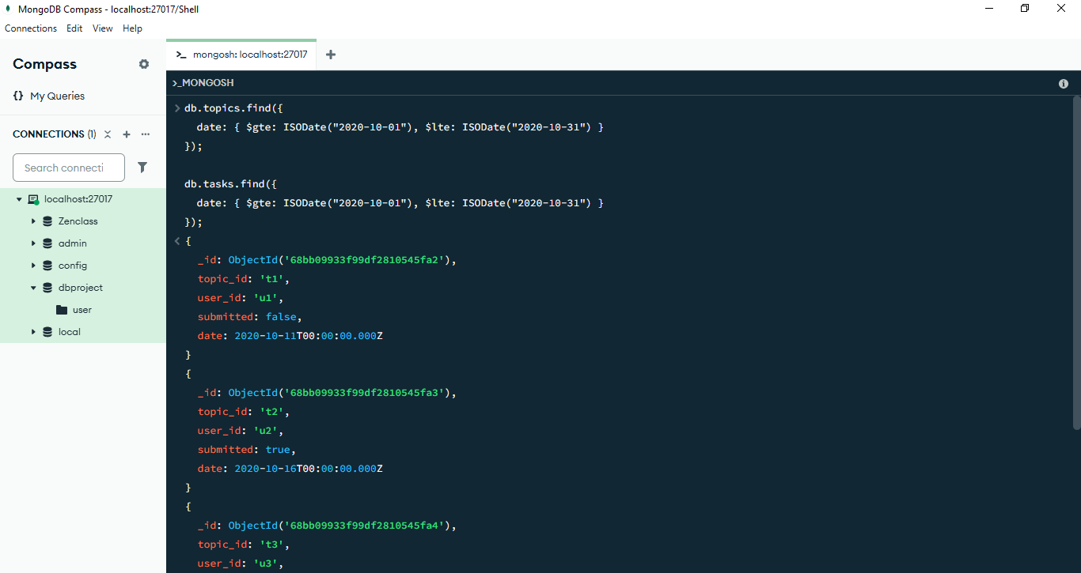

1. Find all the company drives which appeared between 15 oct-2020 and 31-oct-2020

db.company_drives.find({ drive_date: { $gte: ISODate("2020-10-15"), $lte: ISODate("2020-10-31") }});

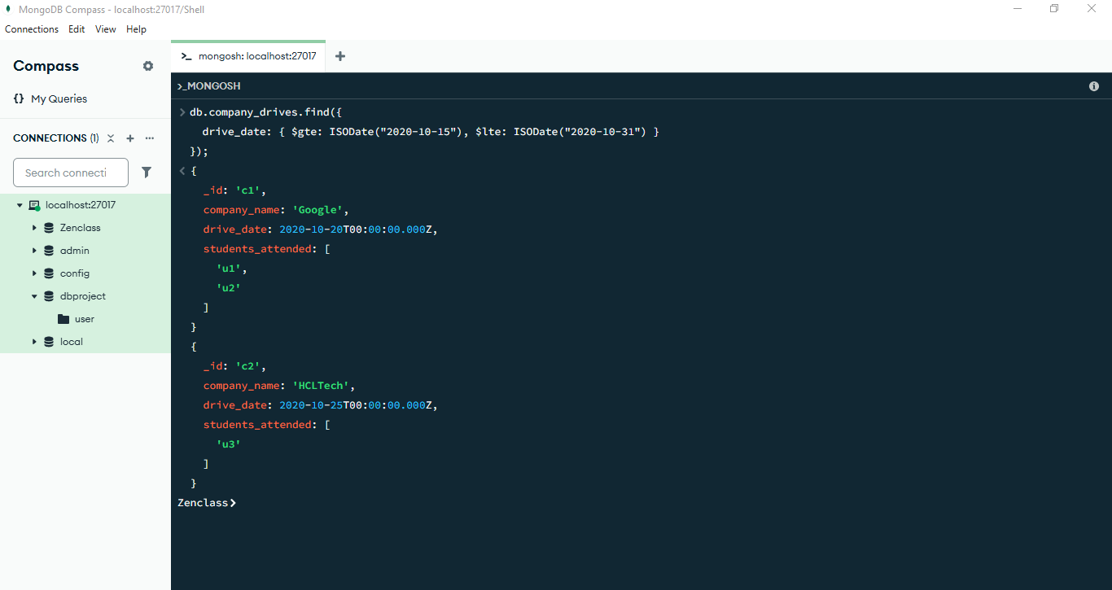

1. Find all the company drives and students who are appeared for the placement.

db.company_drives.find( {}, { company: 1, students_attended: 1, _id: 0 });

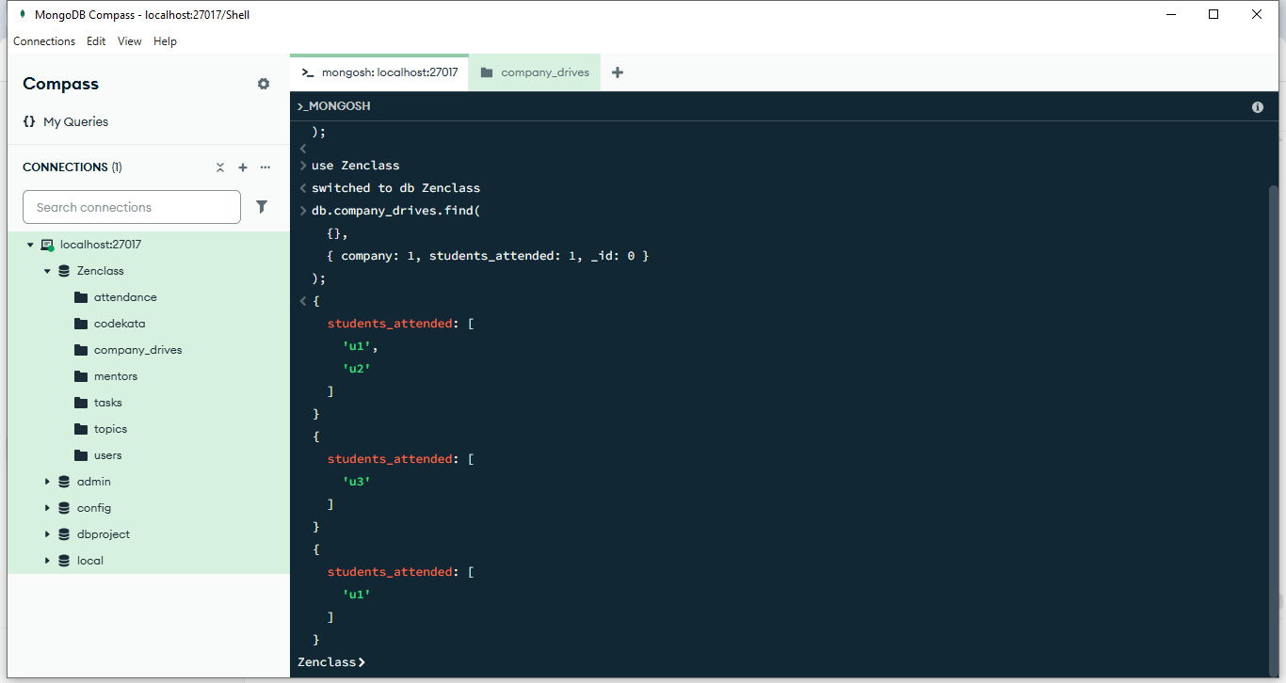

1. Find the number of problems solved by the user in codekata

db.codekata.find({}, { _id: 0, name: 1, problems_solved: 1 });

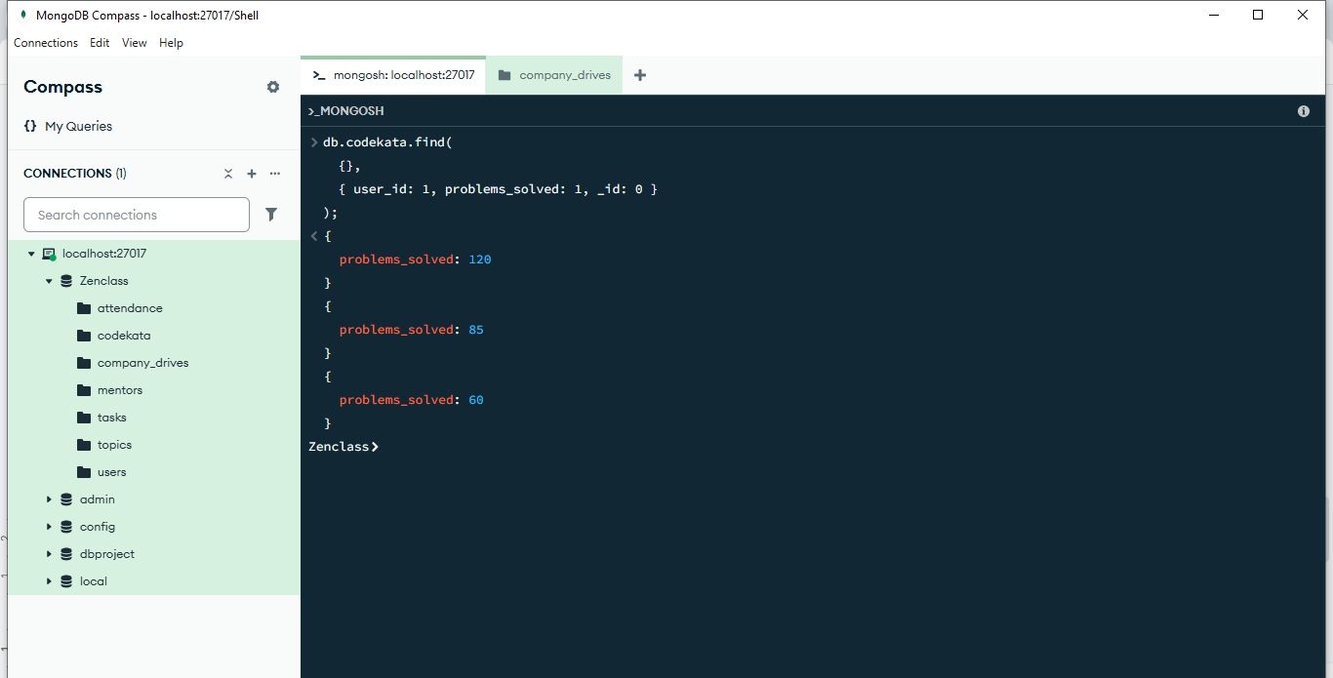

1. Find all the mentors with who has the mentee's count more than 15

db.mentors.find({ mentees_count: { $gt: 15 } });

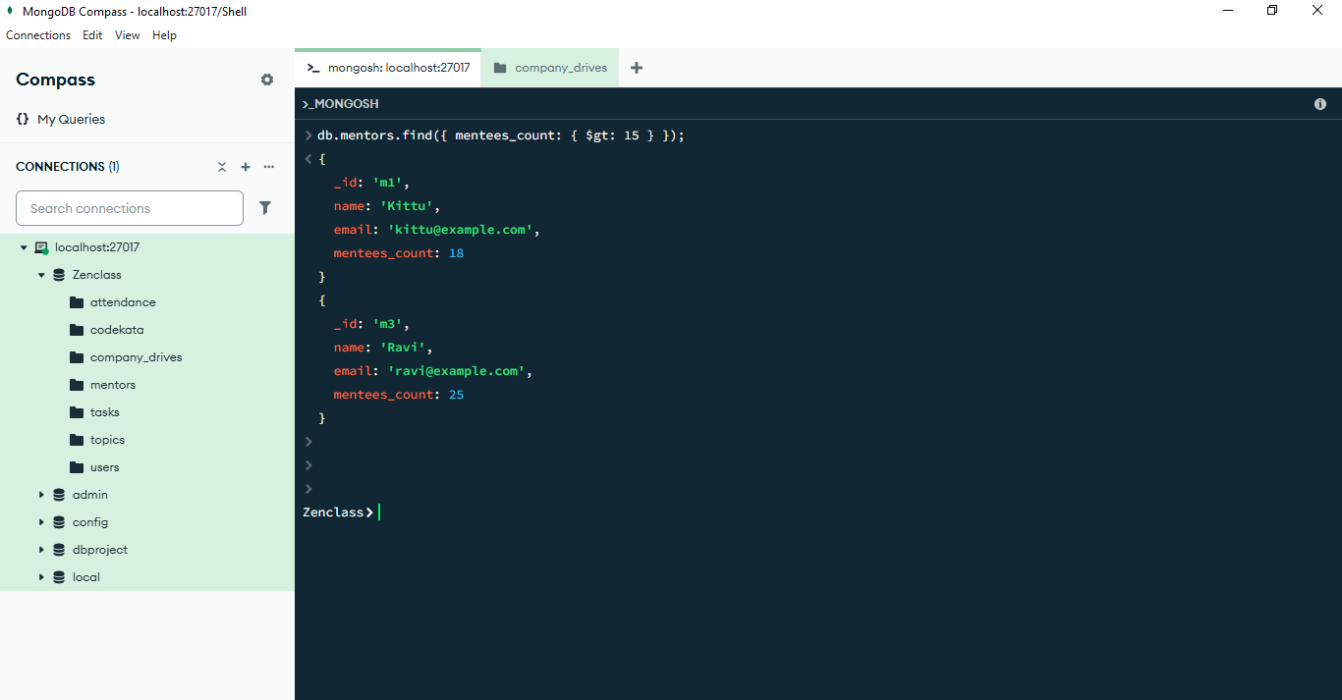

1. Find the number of users who are absent and task is not submitted between 15 oct-2020 and 31-oct-2020

db.attendance.find(

{

status: "Absent",

date: { $gte: ISODate("2020-10-15"), $lte: ISODate("2020-10-31") }

},

{ _id: 0, user_id: 1 });

